First step after launching EC2 Instances

Here $ apt update

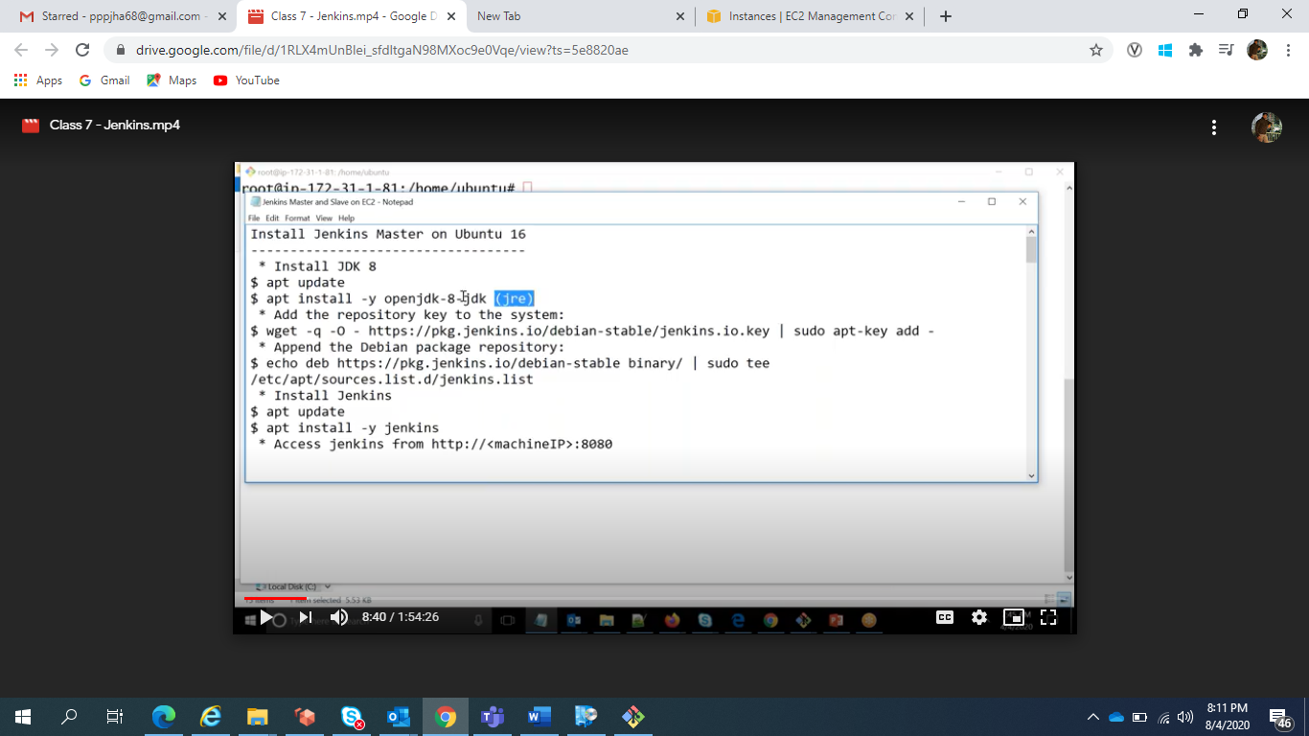

Before installing Jenkins we have to tell from where we have to download the Jenkins

We have to give Jenkins repository

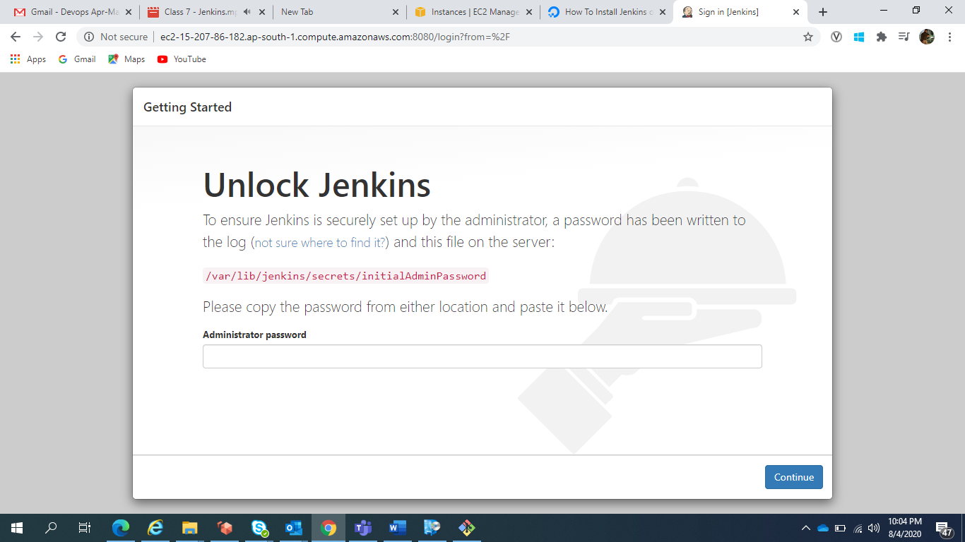

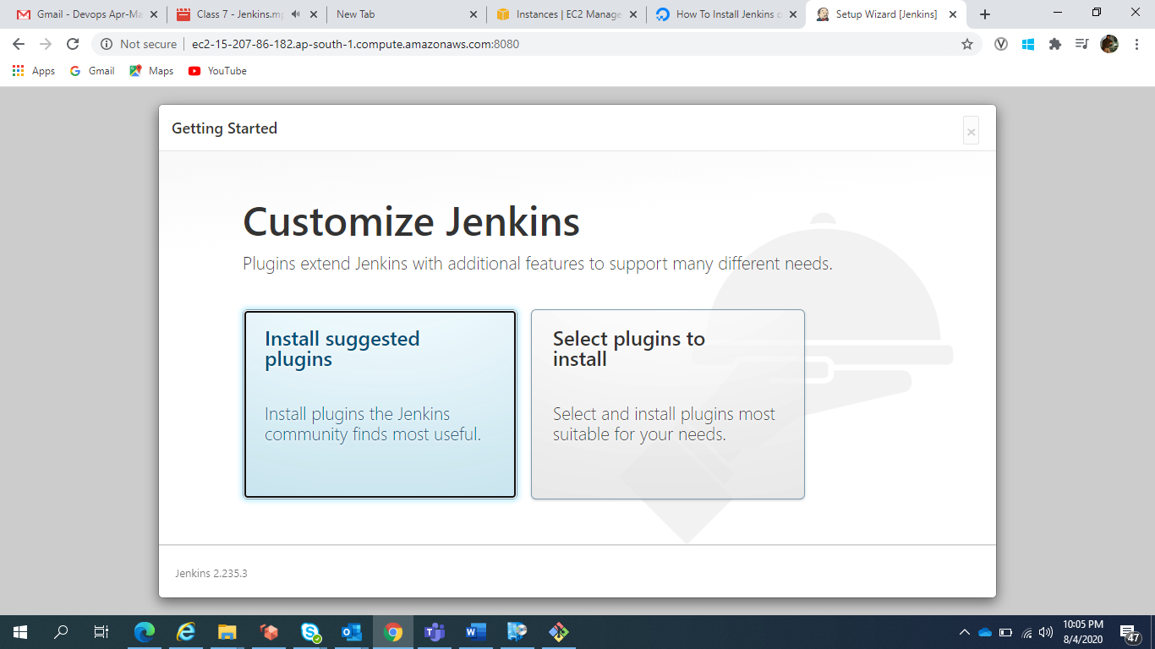

To Connect from Master to slave it required passwordless SSH

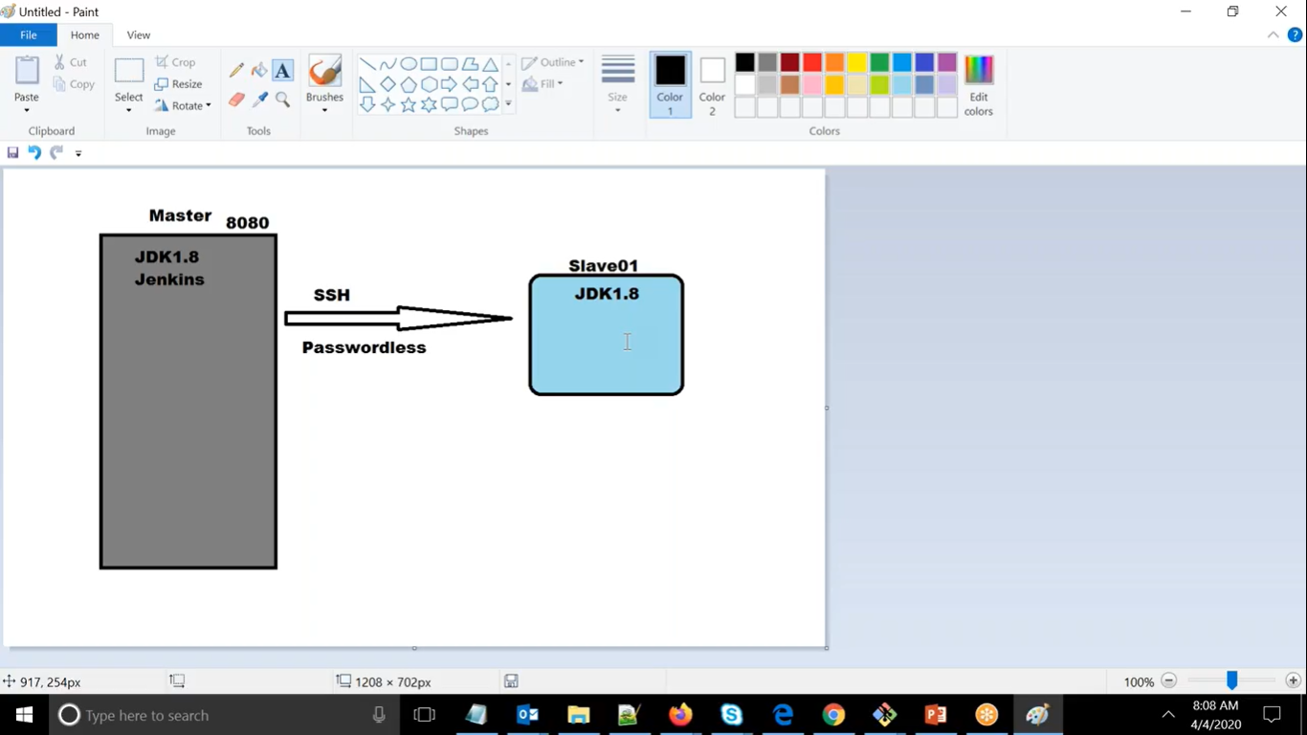

For connecting to other machine we required username and since here we are using ubuntu machine so we will have ubuntu user and here both master and slave should have same username

For this we have to create a service account but here we are using ubuntu.

For connecting to slave machine we should have same key to the slave machine as well.

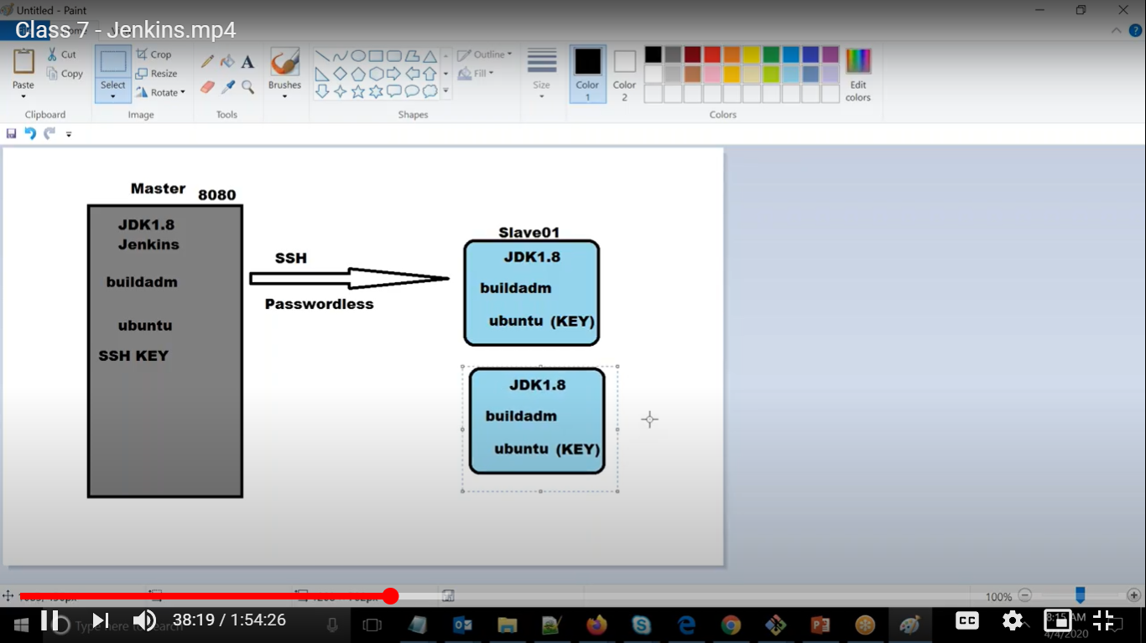

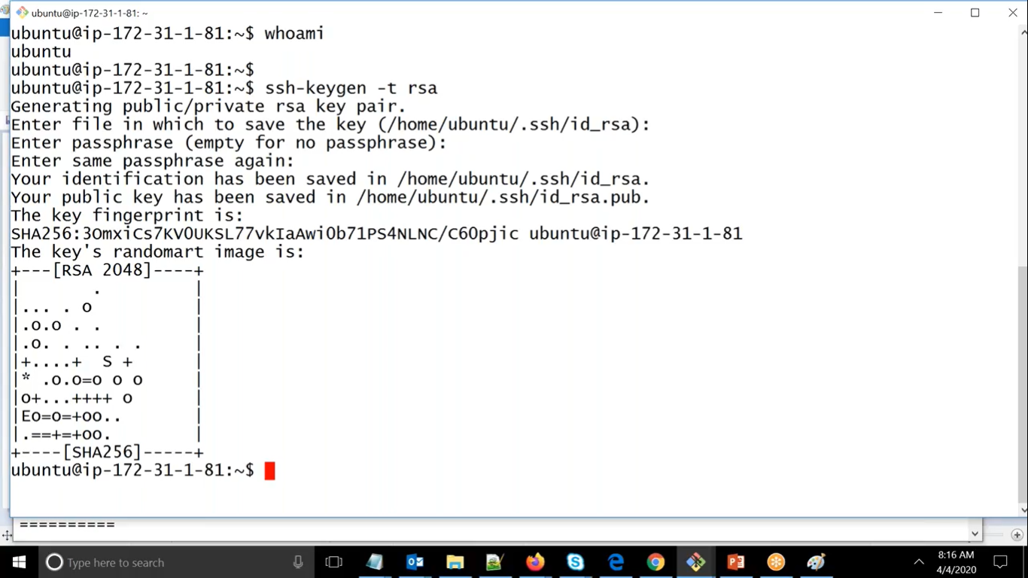

We have to generate the key using above command.

Jenkins Setup

===========

Install Jenkins Master on Ubuntu 16  
-----------------------------------  
 * Install JDK 8  
$ apt update  
$ apt install -y openjdk-8-jdk  
 * Add the repository key to the system:  
$ wget -q -O - [https://pkg.jenkins.io/debian-stable/jenkins.io.key](https://www.google.com/url?q=https%3A%2F%2Fpkg.jenkins.io%2Fdebian-stable%2Fjenkins.io.key&sa=D&sntz=1&usg=AFQjCNE4jekA1T-_IIsI03Yvt0PjF6FHMQ) | sudo apt-key add -  
 * Append the Debian package repository:  
$ echo deb [https://pkg.jenkins.io/debian-stable](https://www.google.com/url?q=https%3A%2F%2Fpkg.jenkins.io%2Fdebian-stable&sa=D&sntz=1&usg=AFQjCNHbLS1PYZCeC5GwldvOsf1EmiF0xQ) binary/ | sudo tee /etc/apt/sources.list.d/jenkins.list  
 * Install Jenkins  
$ apt update  
$ apt install -y jenkins  
 * Access jenkins from http://<machineIP>:8080  
  
Create Slave on Ubuntu 16  
-------------------------  
$ apt update  
 * Install JDK  
$ apt install -y openjdk-8-jdk(apt install -y default-jre)  
 * Install Docker  
$ apt install -y [docker.io](http://www.google.com/url?q=http%3A%2F%2Fdocker.io&sa=D&sntz=1&usg=AFQjCNFHp7lm0nrAT_82lz5WG2p38DfAPw)  
  
 * Run as ubuntu user on master  
$ ssh-keygen -t rsa  
 * Take the content of ~/.ssh/id_rsa.pub (as ubuntu user) from master & put it in ~/.ssh/authorized_keys on slave as ubuntu user  
x  
Slave node setup

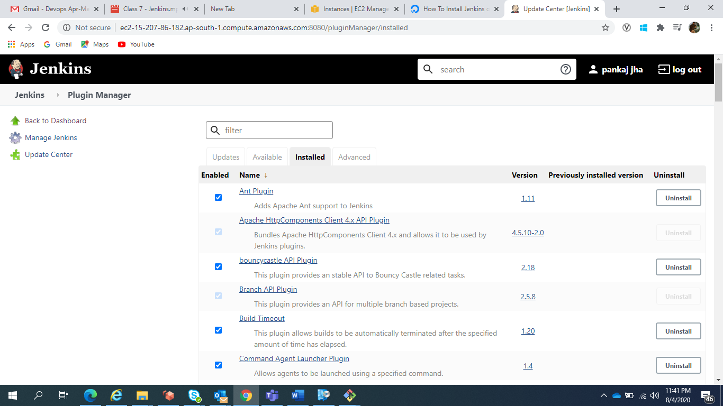

For installing Any plugins we can come here and install the plugins and we can choose it either proceed with restart or not, Everything needs to done in master machine only.

NODES CONFIGURATION

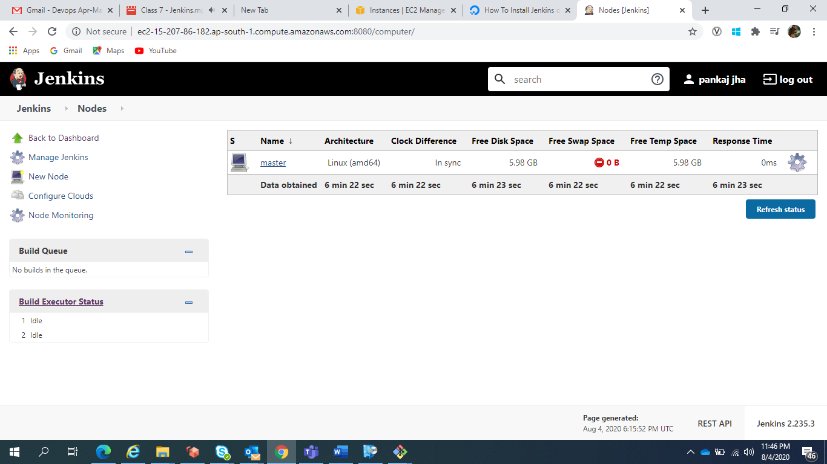

Here we can see one machine is already configured.

SO If we run any thing i.e. job then it will run on this same machine so we will use slave machine so that load will not be increasing here

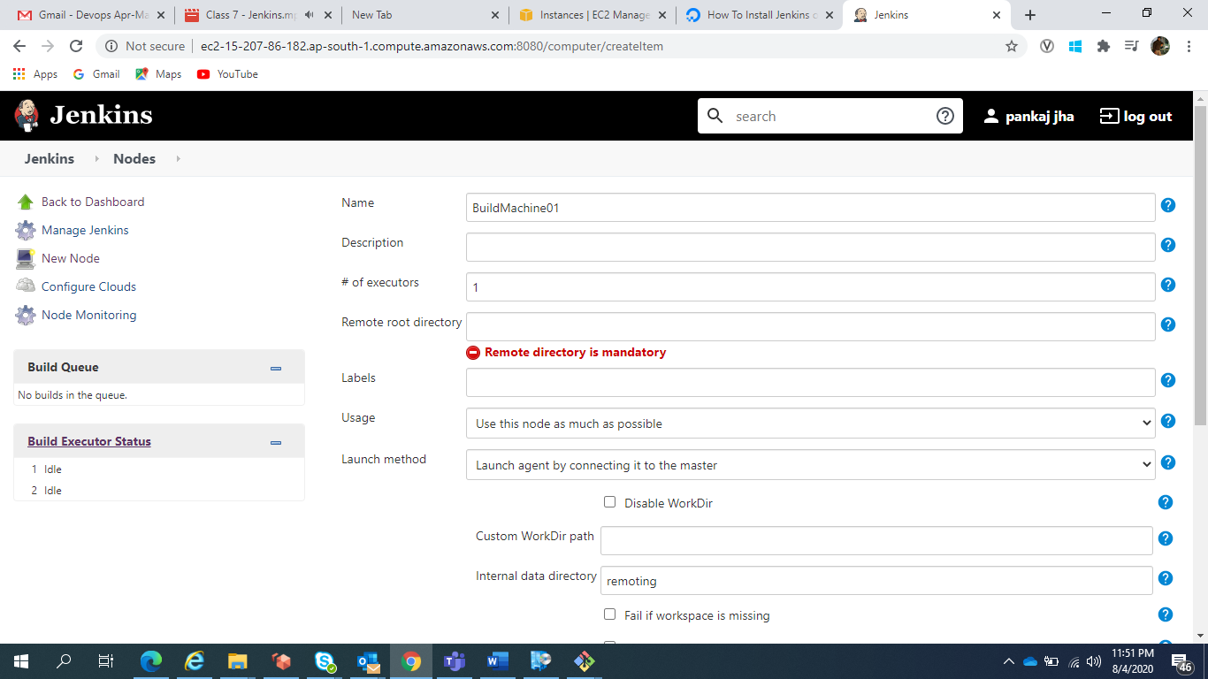

# of executors :- At any time Jenkins master can connect to slave and run 1 job if it is 1, if it is connecting to slave and run 1 job.

It means how many parallel task Jenkins connect to slave and run it.

Remote root directory :- /tmp/Jenkins

For doing any job slave will go to this path and perform the task in this path only

Labels :- A reference name for your group

Usage :- use as much as possible then it will pick this machine only so better to put only build jobs with label expression matching the node.

Launch method :- How master will connect to slave machine

Slave node setup  
----------------  
 * Add new node & make sure the Remote Root directory has read/write permission for ubuntu user  
 * choose Launch method as "SSH"  
  - Give the private IP of the EC2 slave for "Host"  
  - Add Credentials, choose Kind as "SSH Username with private key"  
  - Give user name as "ubuntu" & put the content of "~/.ssh/id_rsa" from master as ubuntu & put it as private key content  
  - Choose 'Host Key Verification Strategy' as "Manually trusted key verification strategy"

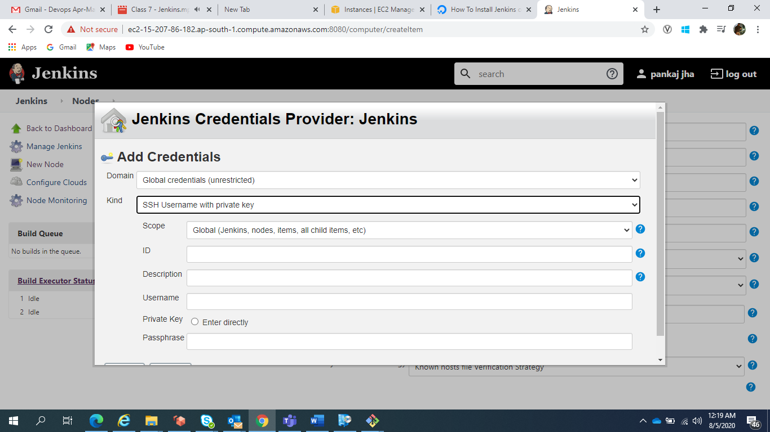

For adding passwordless key

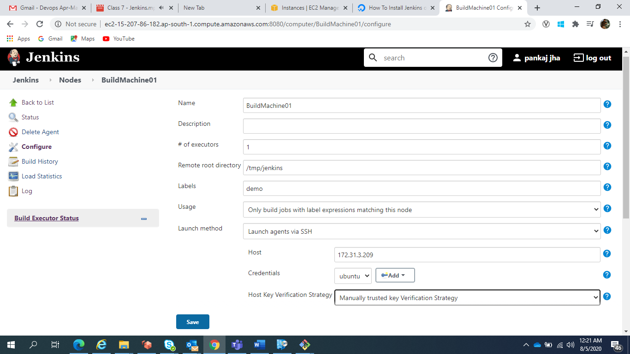

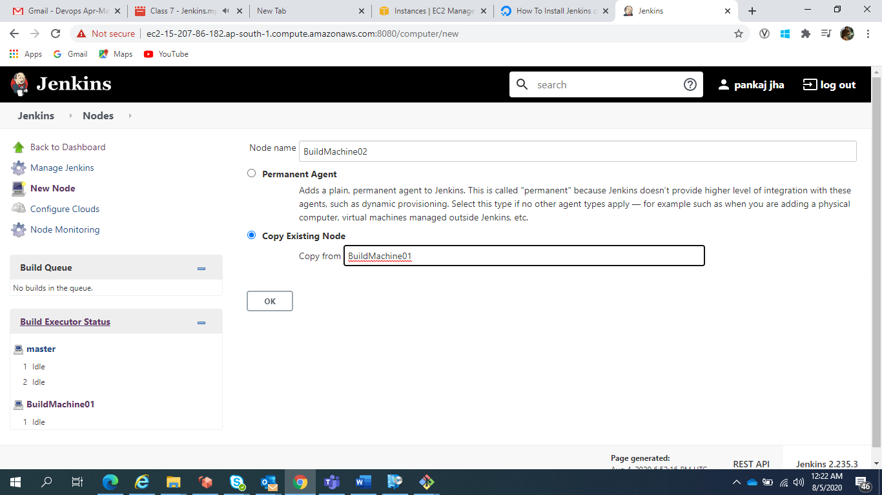

For adding one more machine we can copy existing machine

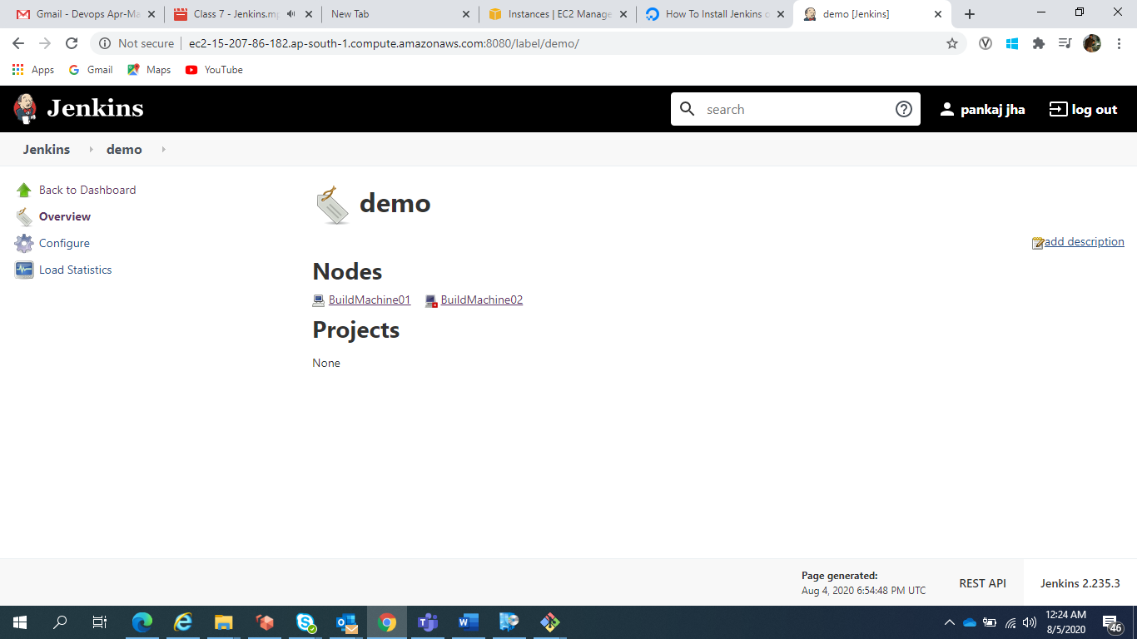

Now we have 2 machines in demo group

We cannot delete the master machine

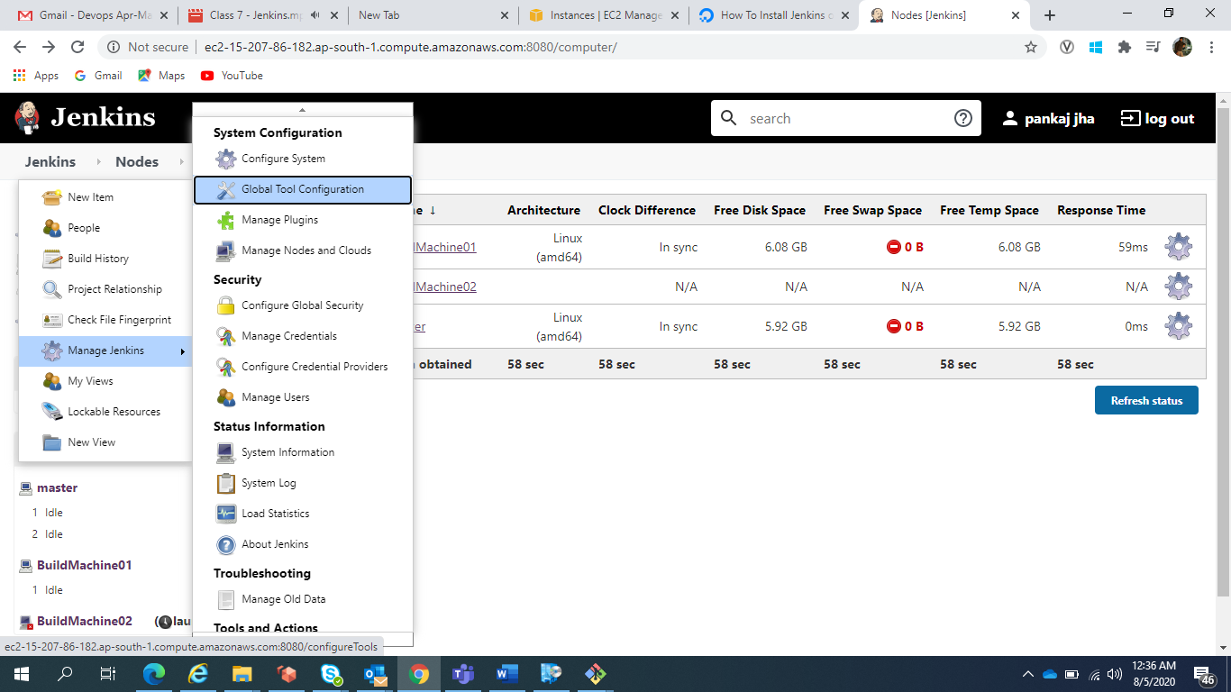

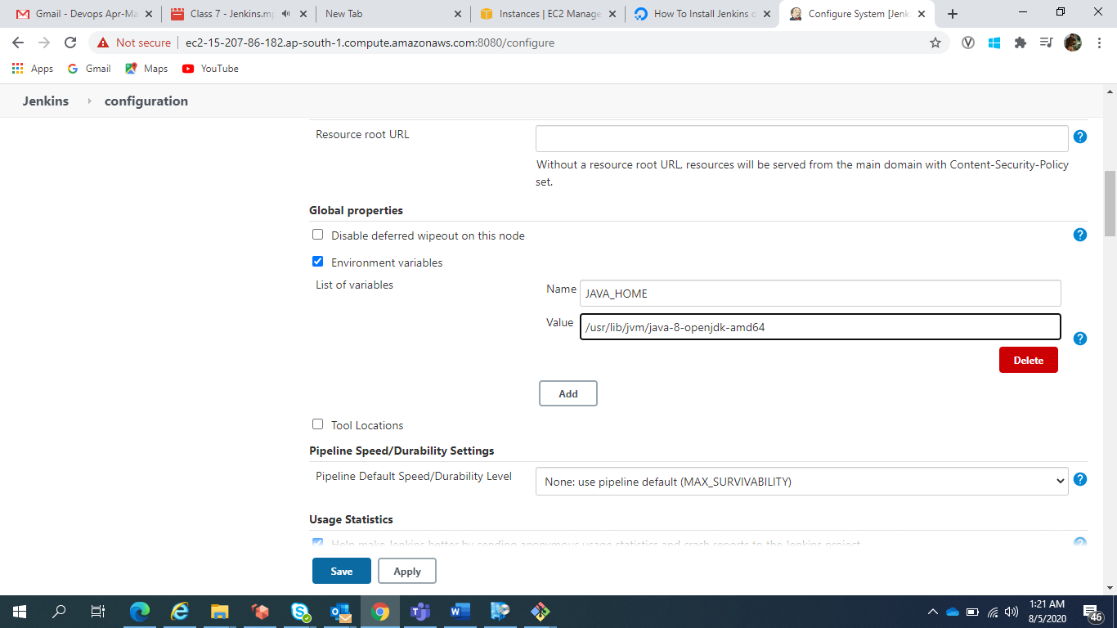

Remember Tools and Environment Variable will be set globally.

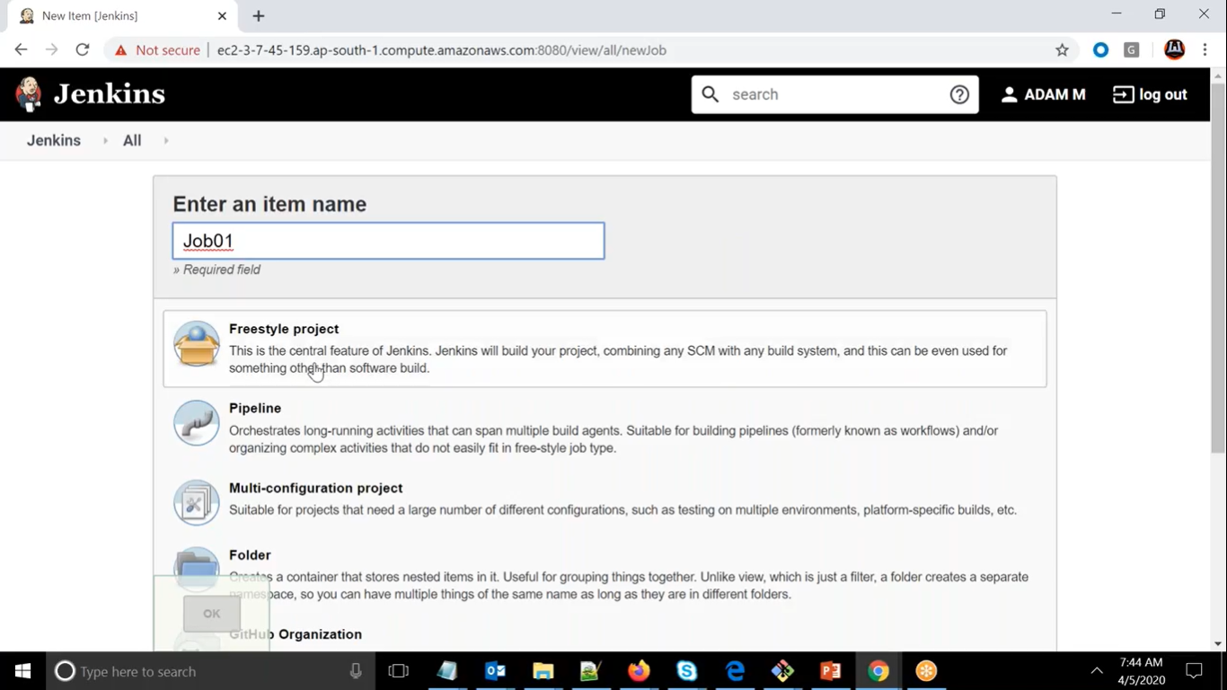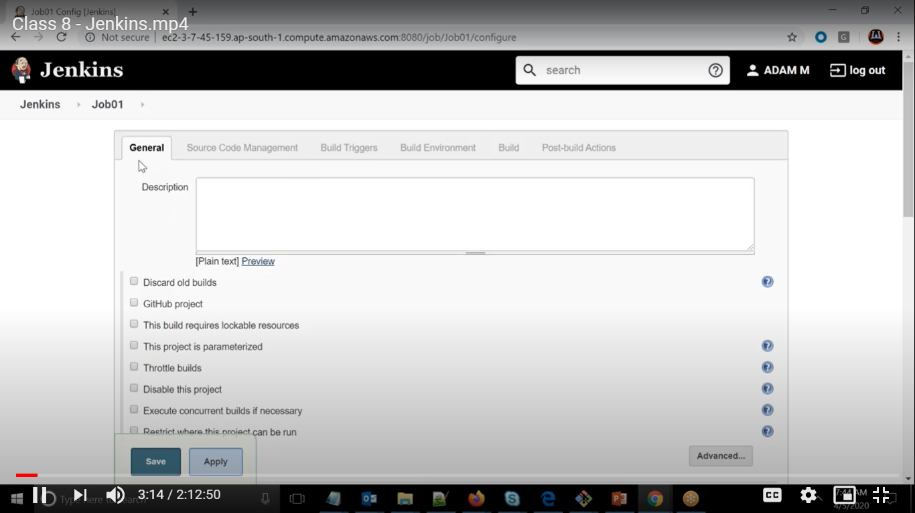

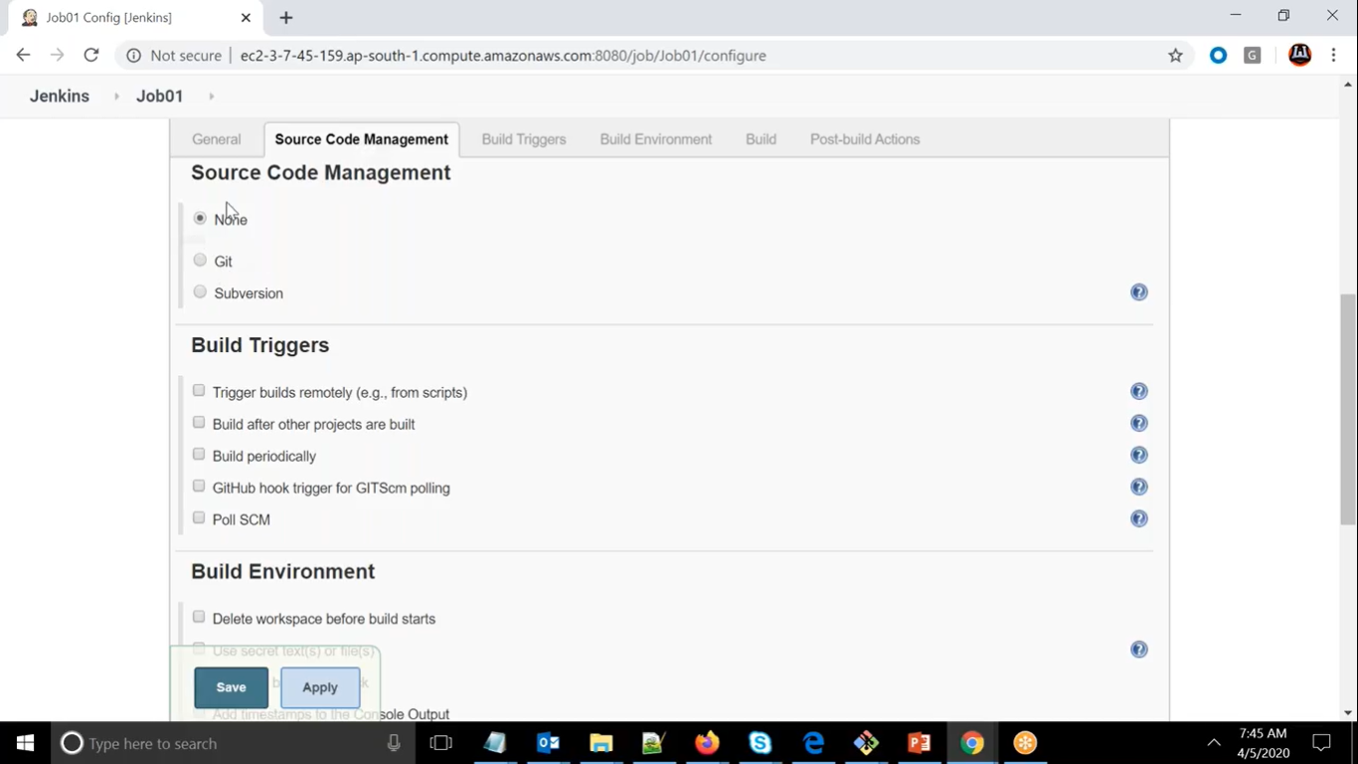

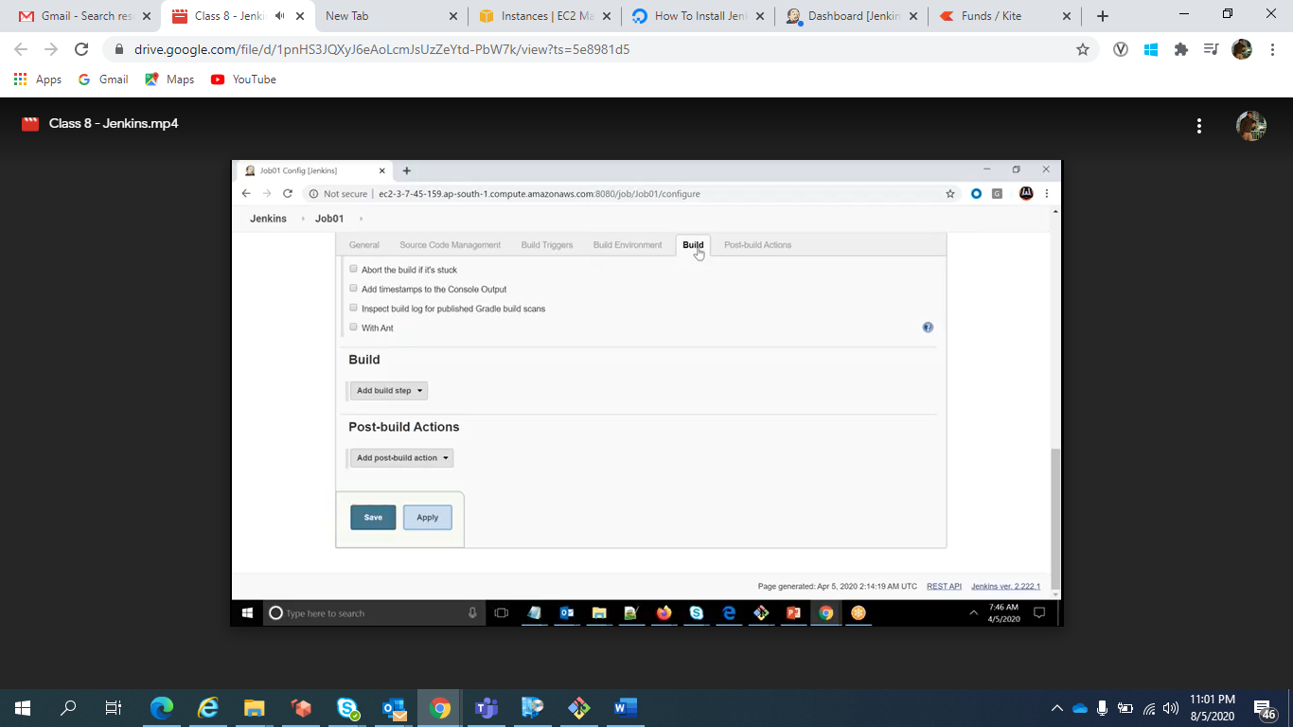

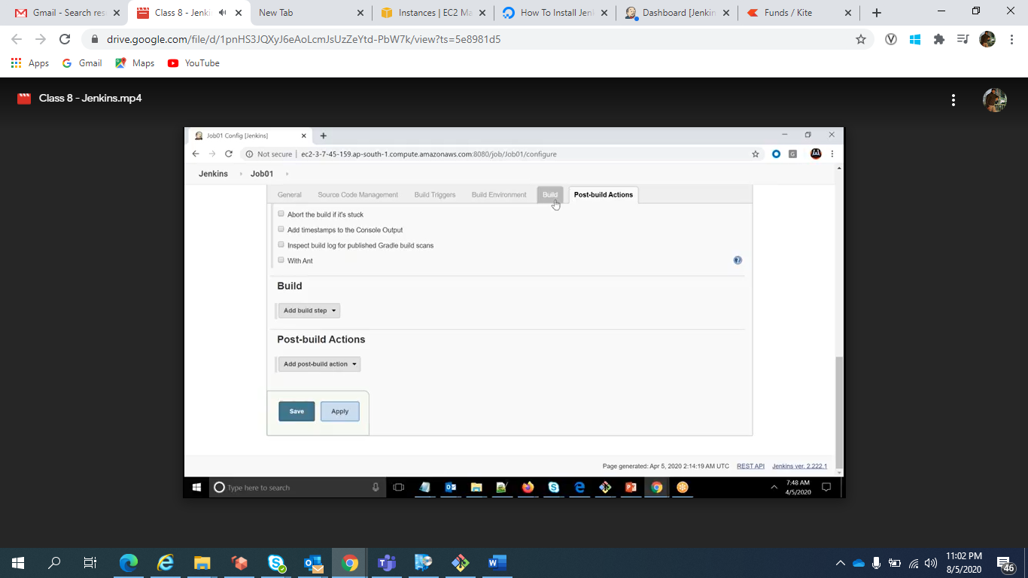

For Connecting slave machine and do work, we will use execute shell

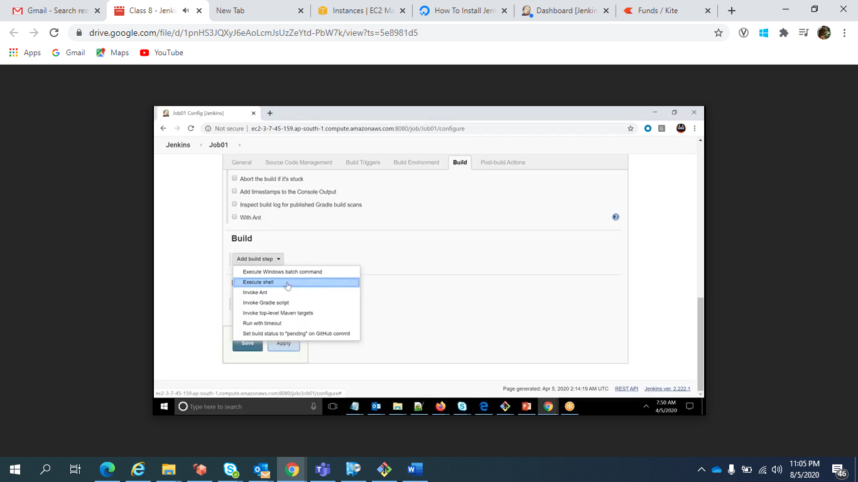

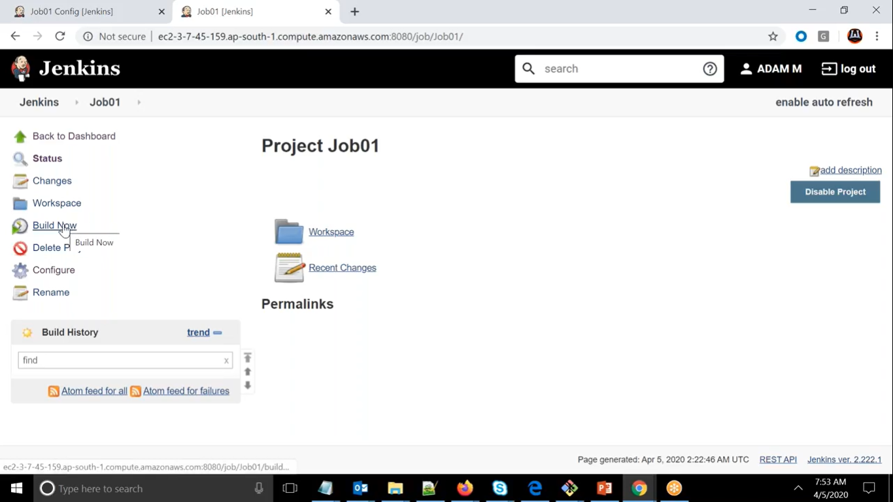

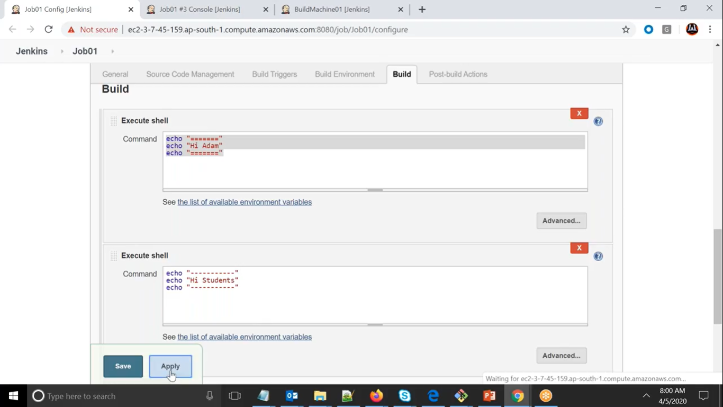

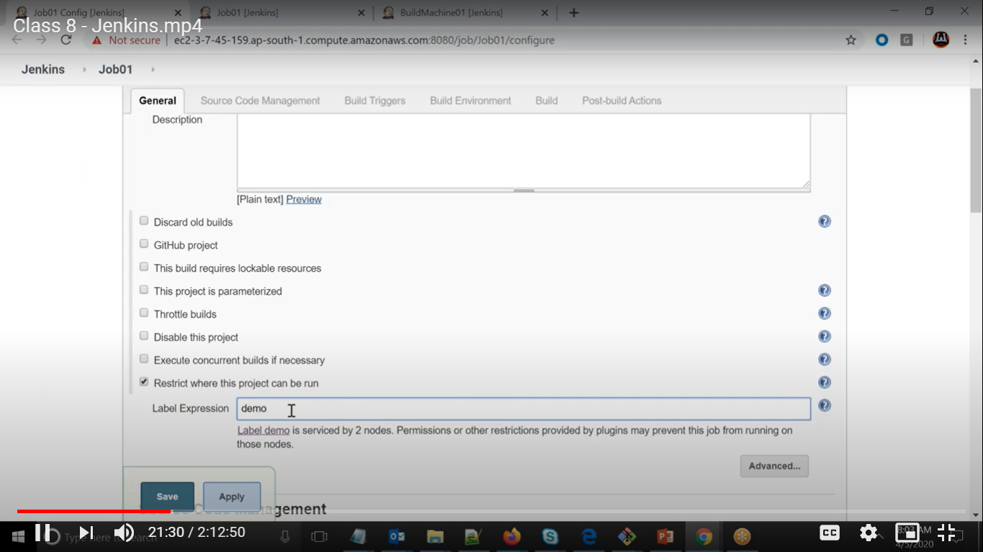

If you get nonzero output means command didn’t run successfully.

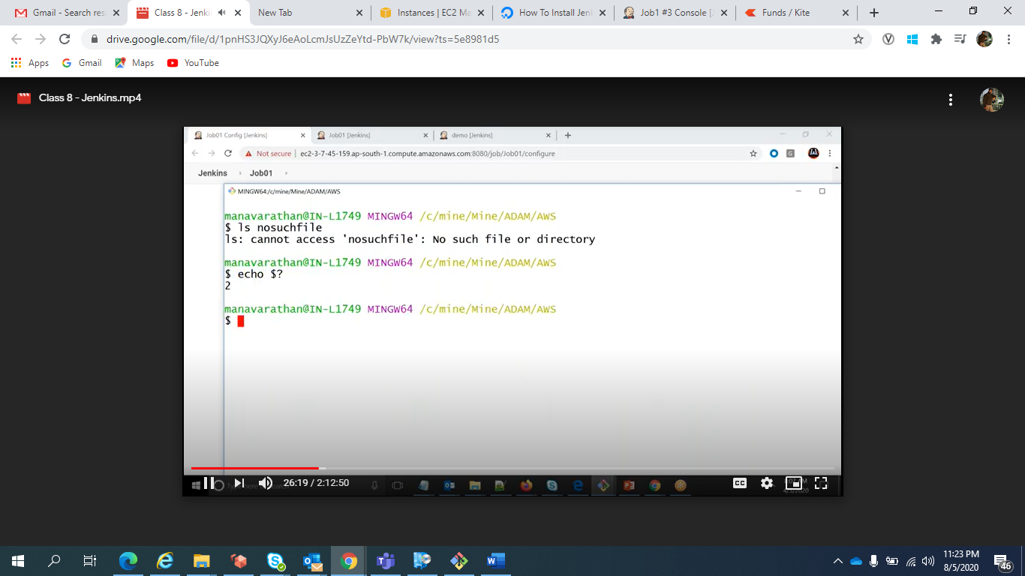

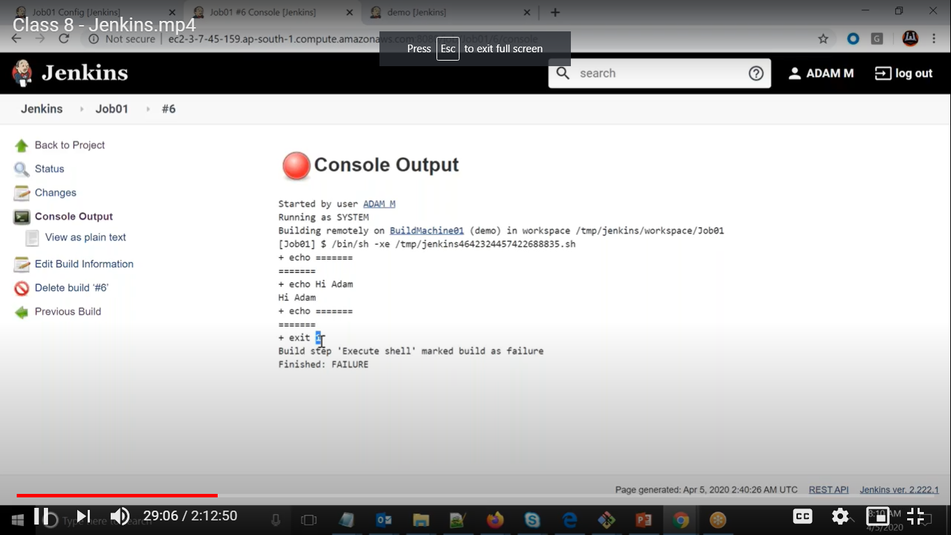

It will exit if it is non zero and failed

For any jobs after remote root directory it will create workspace as workspace and then job number.

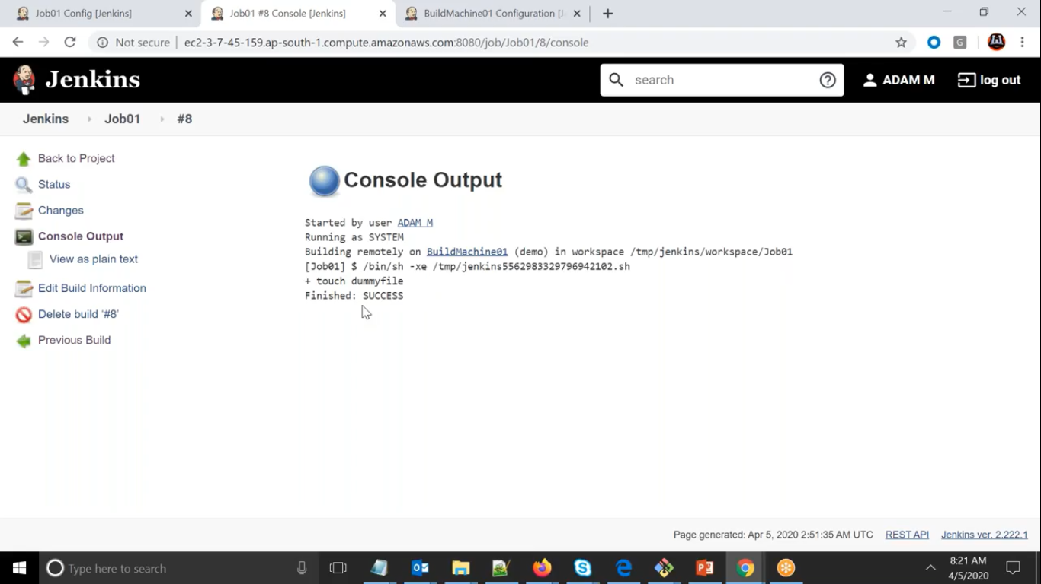

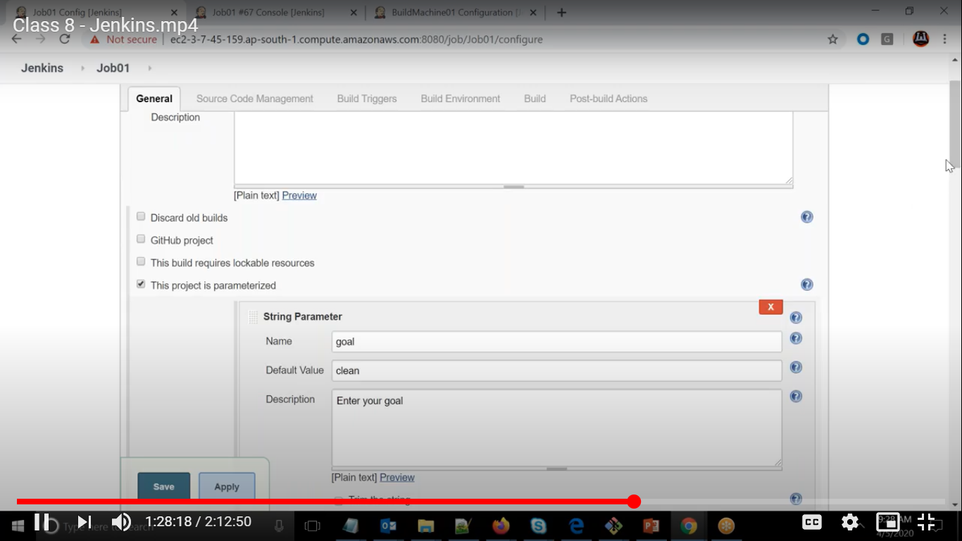

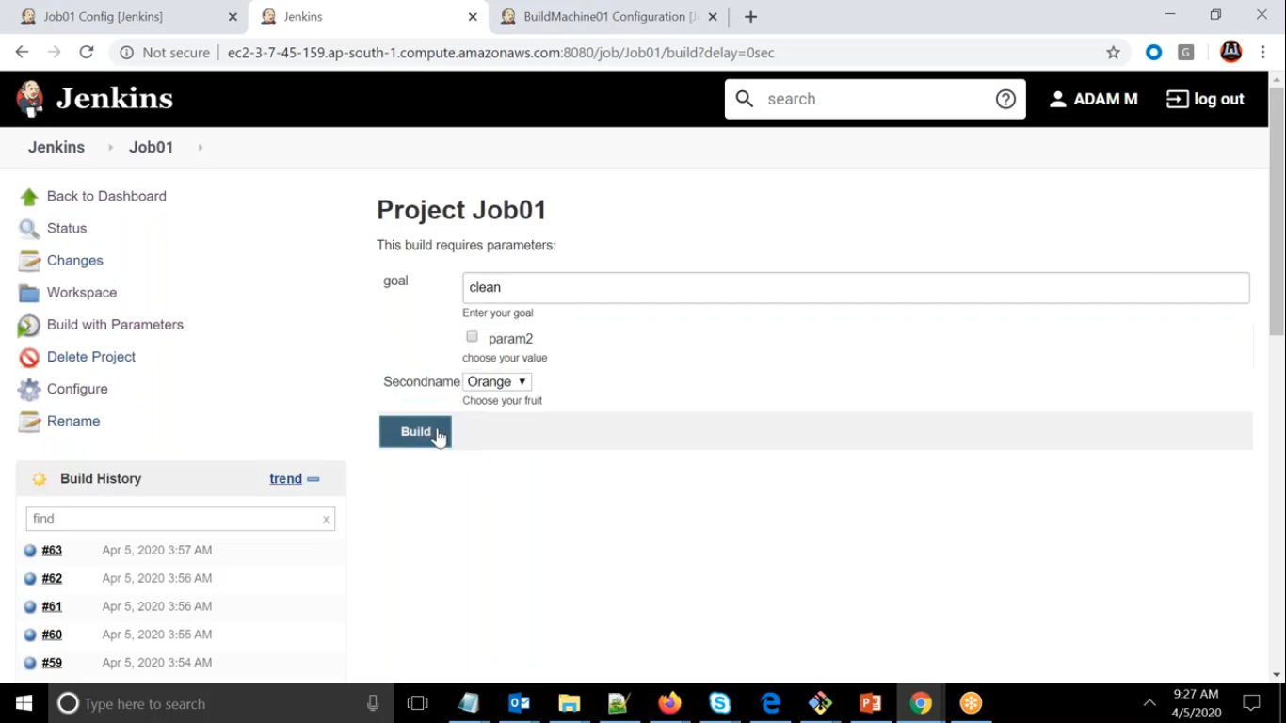

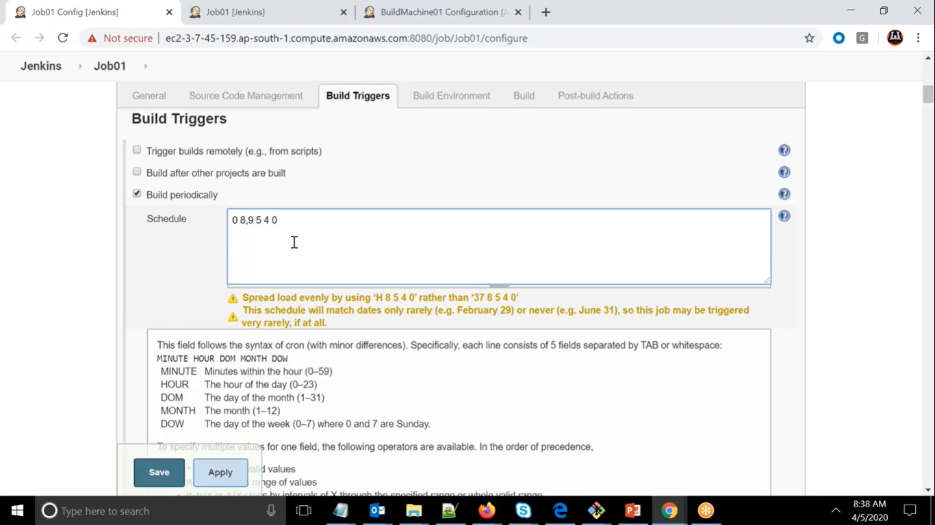

If we want to run on 8 and 9th hour then we can give 8,9

We can select range as well

0 8,9 5-12 4 0

Here range is 5-12 means from 5 to 12

Here * means all

If we mention every minute and by that time if it does not completed then it will wait till its completed

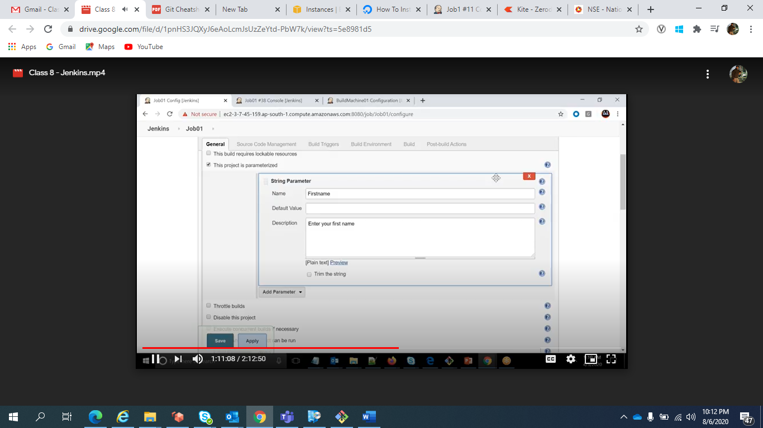

Whatever value we will pass it will store as Env Variable only

We can fetch it as below and if no name is given we can pass default value as well

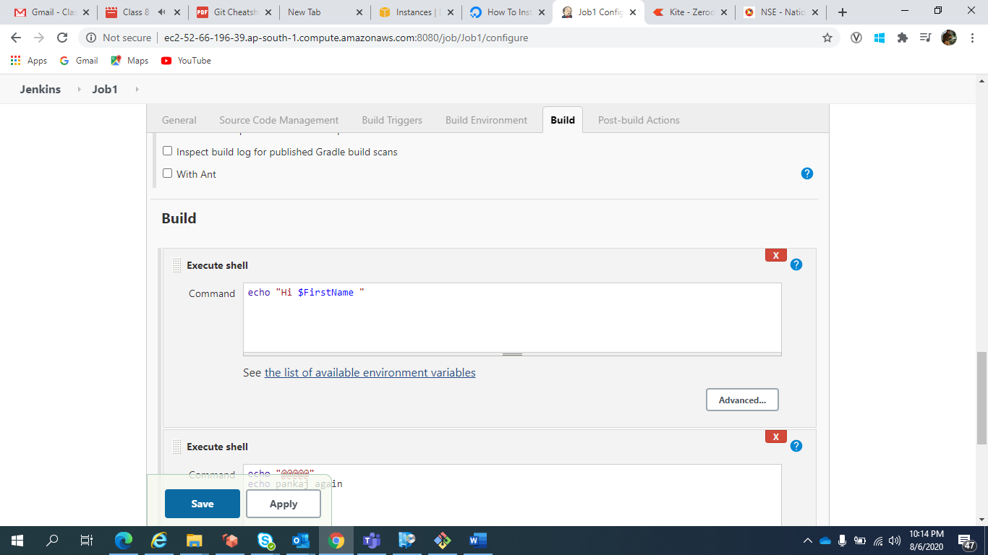

In Choice Parameter Default Value will be first Choice

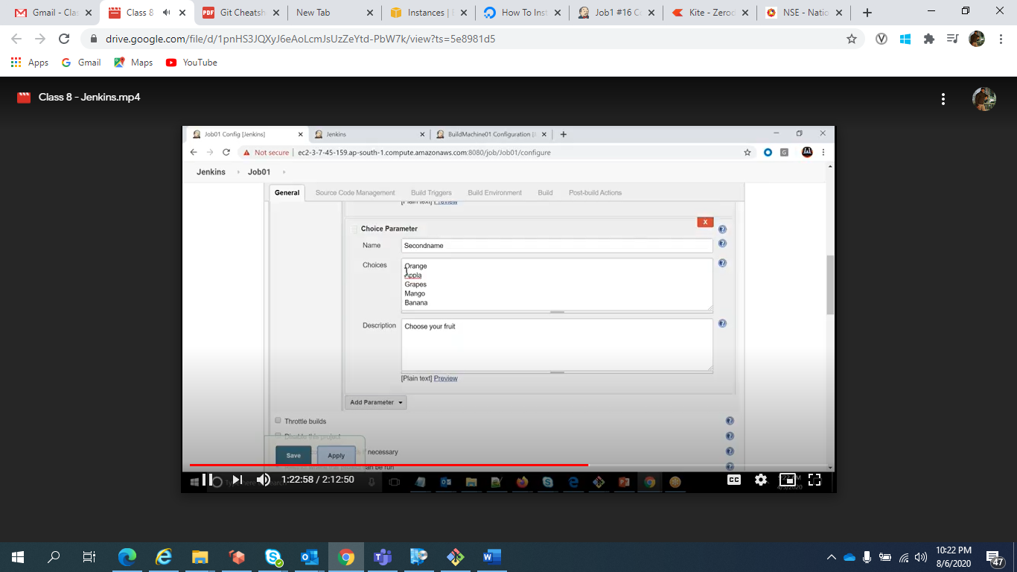

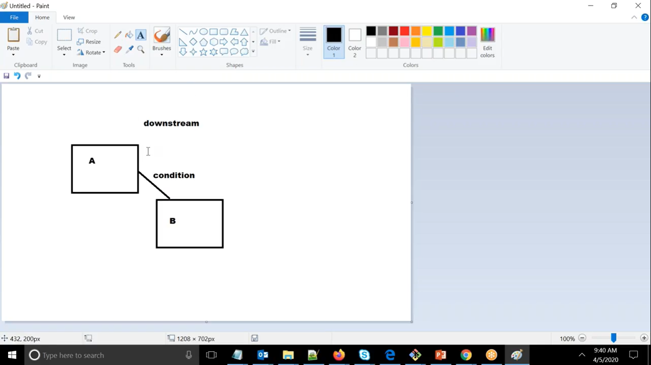

DownStream means only when A job is completed then we will go for B

For this we will use postbuild

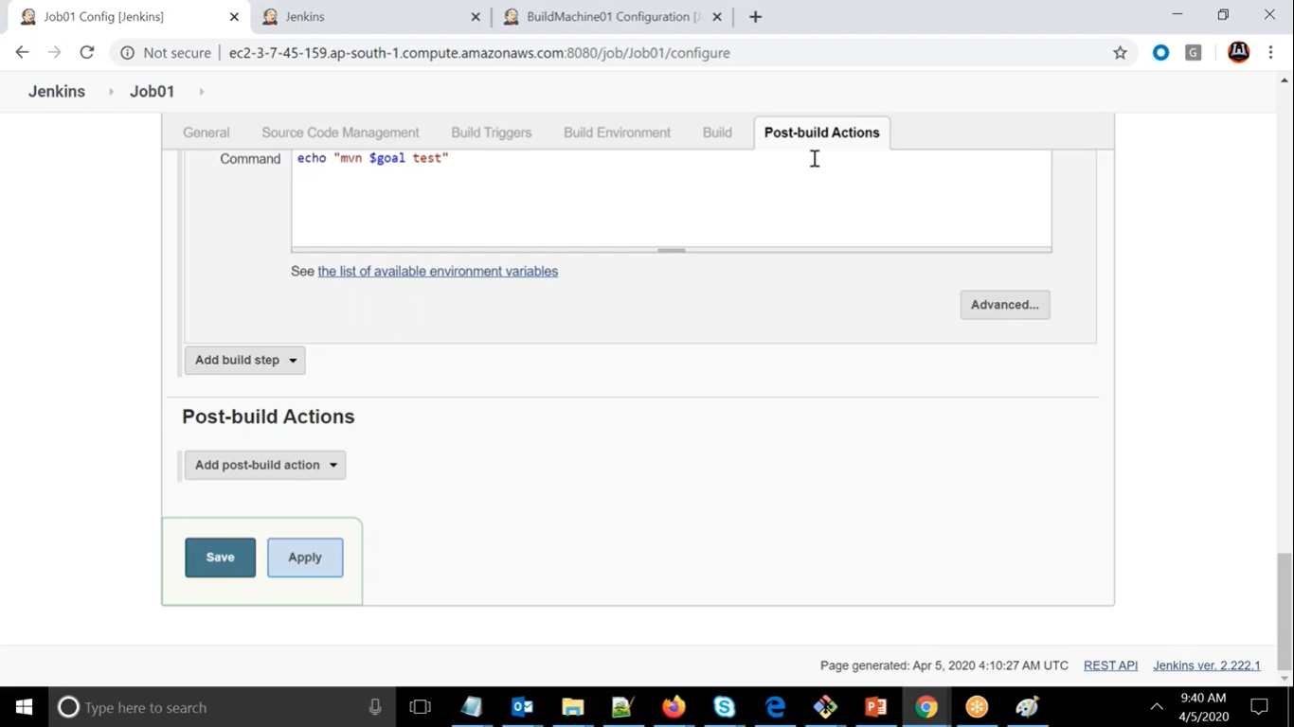

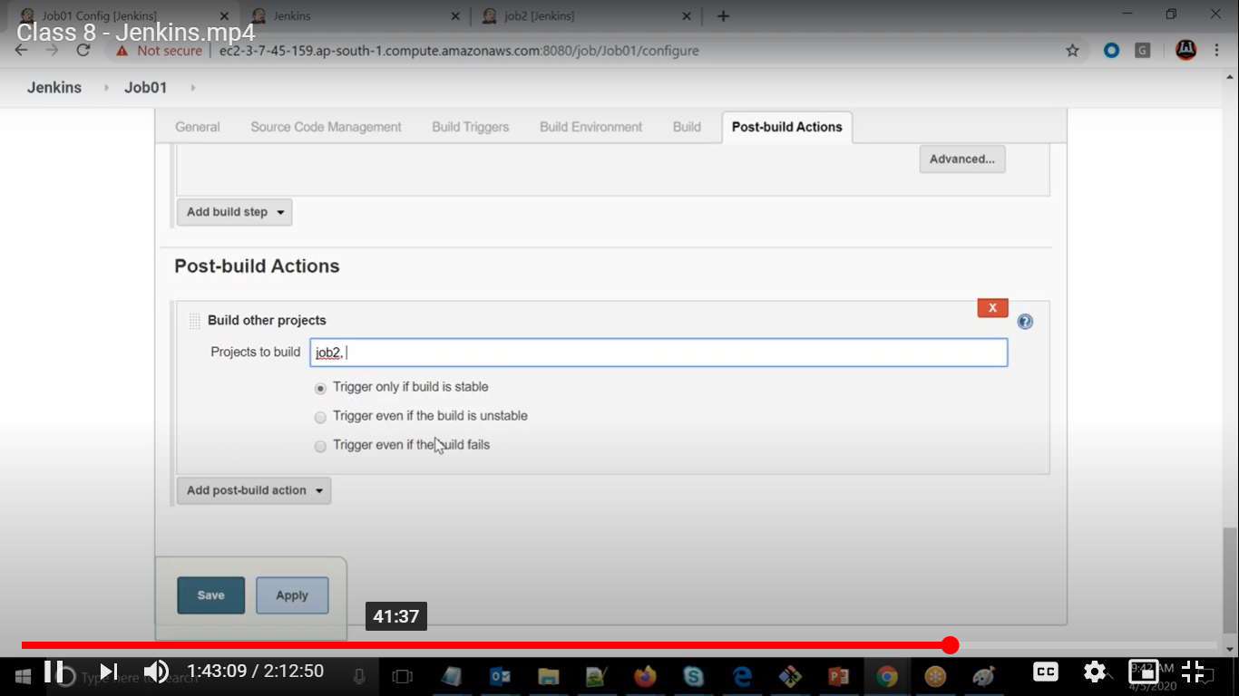

You can pass other jobs you can mention it as if it is stable

We can use upstream parameter as well by installing parameterized plugin

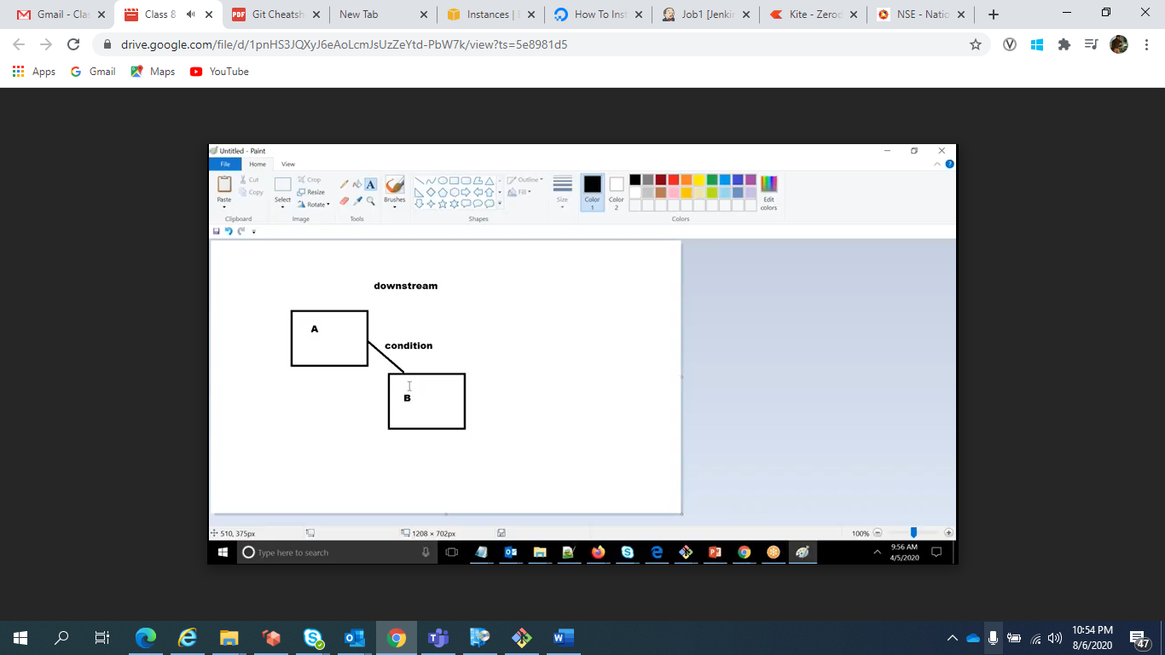

We can call second job by reading the file

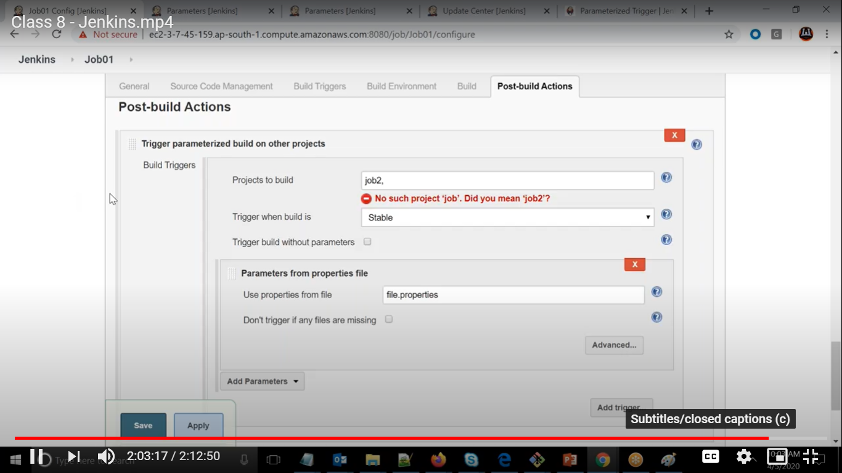

But file should be available in remote root directory

We can run both the job in same node

